Parallel

Replenishment Calculation

Memo
LS Central (20.0)

Contents
1 Introduction 1
2 Replenishment Calculation Using Multiple NAS 2
2.1 Configuring the NAS 2
2.1.1 Having the NAS Run a Single Task 3
2.1.2 Having the NAS Run Multiple NAS Tasks 4
2.2 Running Replenishment Item Quantity (RIQ) Calculation in Parallel with NAS 5
2.2.1 Configuring NAS for Parallel Processing 5
2.2.2 Configuring the Primary NAS 5
2.2.3 Configuring Scheduler Job for Parallel Processing 6
2.2.4 Configuring Master Scheduler Job and Linked Scheduler Jobs 7
2.3 Running Out-of-Stock (OOS) Calculation in Parallel with NAS 9
2.3.1 Configuring NAS for Parallel Processing 9
2.3.2 Configuring the Primary NAS 9
2.3.3 Configuring Scheduler Job for Parallel Processing 9
2.3.4 Configuring Master Scheduler Job and Linked Scheduler Jobs 10
3 Replenishment Calculation Using Background Sessions 11
3.1 Running Replenishment Item Quantity (RIQ) Calculation in Parallel with Background Sessions 11
3.1.1 Configuring Scheduler Job for Parallel Processing 11
3.1.2 Configuring Master Scheduler Job and Linked Scheduler Jobs 12
3.2 Running Out-of-Stock (OOS) Calculation in Parallel with Background Sessions 14
3.2.1 Configuring Scheduler Job for Parallel Processing 14
3.2.2 Configuring Master Scheduler Job and Linked Scheduler Jobs 14

Introduction

The calculation of Purchase Orders and Transfer Orders in LS Replenishment is done in three steps:
- Calculation of Out-of-Stock
- Calculation of Replenishment Item Quantity
- Calculation of Replenishment journals

The processing time strongly depends on the number of items, variants, and locations to be considered in the calculation and can take multiple hours.
This memo covers the setup to calculate Replenishment Item Quantities (RIQ) and Out-of-Stock (OOS) using a parallel calculation approach. The purpose of this approach is to reduce the processing time for the calculation.
There are two methods of parallel calculation:
- Replenishment calculation using multiple NAS
- Replenishment calculation using background sessions

LS Central on-premises users can opt to use either method. LS Central SaaS users can use the background sessions method which is compatible with the SaaS environment.

Replenishment Calculation Using Multiple NAS

Configuring the NAS

In classical setups, one NAS is used to process a job for the Job Scheduler.
In the parallel approach, we add more NAS to distribute the workload among those additional services. It is not necessary to host the additional NAS on separate, individual servers or VMs, but we recommend having one server or VM for the primary NAS and a separate server or VM to host all the additional NAS.

Example1:
- SERVER1: Microsoft SQL Server
- SERVER2: Client Services & primary NAS
- SERVER3: NAS1 (for parallel processing)
- SERVER4: NAS2 (for parallel processing)

Example2:
- SERVER1: Microsoft SQL Server
- SERVER2: Client Services & primary NAS
- SERVER3: NAS1, NAS2 (for parallel processing)

To configure the NAS, you must open the Microsoft Management Console for the Microsoft Dynamics 365 Business Central Server. It is called “Microsoft Dynamics 365 Business Central Server.msc” and can usually be found in the folder C:\Program Files (x86)\Microsoft Dynamics 365 Business Central\190\RoleTailored Client.



We assume the service has already been set up correctly, so the connection to the database has been established and clients have already connected to the database.
To configure the NAS, open the NAS Services tab for the service you want to configure.

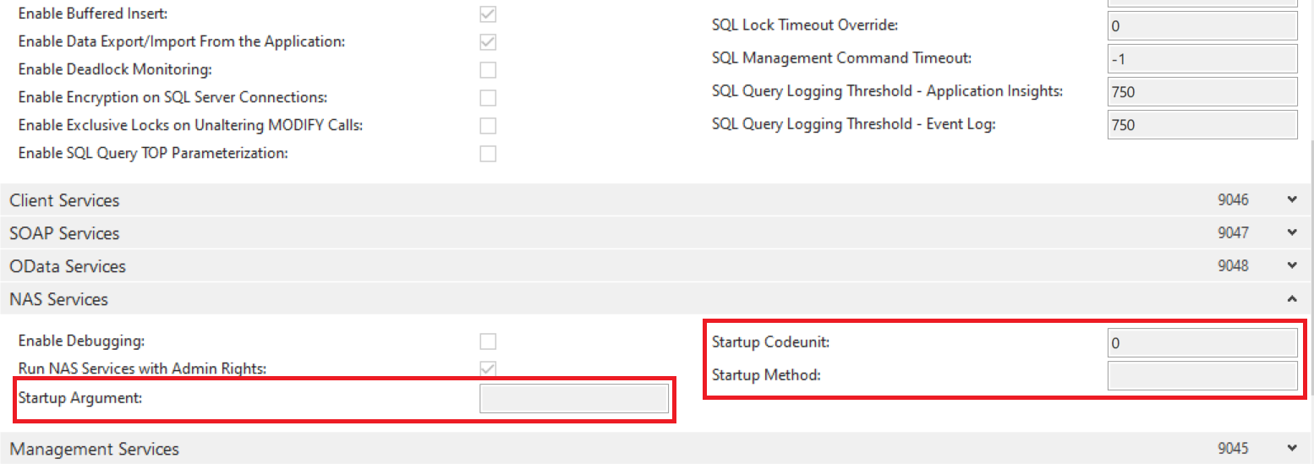

Having the NAS Run a Single Task
If you just want to run one task or codeunit, you can enter the number of your codeunit in the field. This will run the OnRun trigger. Here is an example:

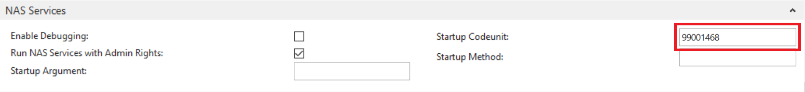

If you want the NAS server to run a function in your codeunit, you need to enter the name of the function in the Startup Method field, and if you want to pass parameters to your function, you can enter them in the Startup Argument. Here is an example of how to have the NAS call the function LSRSCHEDULER in codeunit 99001468 LS NAS Scheduler Service, and pass parameters NASID,TYPEFILTER=DD-FROM-HO|DD-TO-HO|HOSP,LOG=1,REPEAT=1:

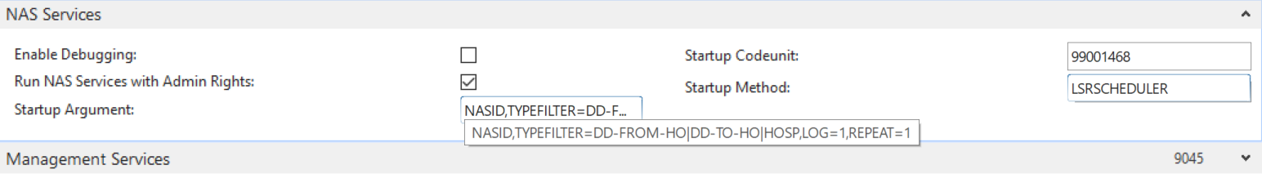

Having the NAS Run Multiple NAS Tasks
If you want the NAS server to run more than one task, you can use Codeunit 99001454 LS Retail NAS Handler and pass parameters to the function LSRETAILNASHANDLER.
You need to enter 99001454 in the Startup Codeunit field and LSRETAILNASHANDLER in the Startup Method. The following four keywords are supported in the parameters passed in the Startup Argument:
- LSRBATCHPOST
- LSRSCHEDULER
If you want to run the LS Retail Batch Posting function, you can enter LSRBATCHPOST in the Startup Argument field. When this service is started, Codeunit 99001454 LS Retail NAS Handler will start 99001466 Run Batch Posting from NAS in a background session.
If your NAS is to run the LS Retail Scheduler, then you should enter LSRSCHEDULER in the Startup Argument field. Please note that the LSRSCHEDULER takes a parameter string. The parameter string must immediately follow the LSRSCHEDULER keyword, and it must be separated by a space. The format of the LS Retail Scheduler parameter is: NASID,TYPEFILTER=[Filter on Scheduler Job Type Code],LOG=[0|1],REPEAT=[0|1].
The NASID can be filled out. It can have any alphanumeric characters (A to Z and 0 to 9). If it is specified, then it must be the first keyword in the parameter string.
The Scheduler uses the NASID for marking jobs that have Run Status = Processing when the Scheduler starts. If the NASID is filled out, the LS Retail Scheduler will mark the Scheduler Job Header with the NASID when it starts a job. When the LS Retail Scheduler is started and it finds a job where Run Status = Processing and it is marked with the same NASID, the LS Retail Scheduler will change the Run Status of the job depending on the value in the Error Handling field. If it is Skip to Next Run, then a new date and time will be calculated for the job, depending on the Time between Check and the Time Units, and the Scheduler will try again at the new time. If the Error Handling is Mark with Error and Retry, then the Scheduler will change the Run Status to blanks and try running it again. And finally, if the Error Handling is Mark with Error and Stop, the Scheduler will change the Run Status to With Error, and it will not try to run it again until the Run Status is changed manually.
In the filter on Scheduler Job Type, you can enter a filter for the jobs you want the LS Retail Scheduler to run. If you want to run all the LS Retail Scheduler jobs, you can omit this parameter or fill it out like this: TYPEFILTER=
An example of how the TYPEFILTER can be filled out: TYPEFILTER=DD-FROM-HO|DD-TO-HO|HOSP
The codeunit that runs the Scheduler (99001469) will apply the type filter (DD-FROM-HO|DD-TO-HO|HOSP) to the jobs that it will run, so only jobs that have DD-FROM-HO, DD-TO-HO, or HOSP will be selected and run by this NAS.
The LOG parameter can be set to either 0 or 1. If it is set to 0 (LOG=0), the system will not enter any lines in the Scheduler Log. If the parameter is set to 1 (LOG=1), the system will enter one line into the Scheduler Log, every time the job is run.
The REPEAT parameter can be set to either 0 or 1. If it is set to 0 (REPEAT=0), the task is only run once, but if the parameter is set to 1 (REPEAT=1), the task will run until it is shut down.

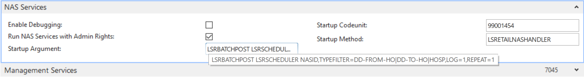

Note: The keywords (LSRBATCHPOST, LSRSCHEDULER) and parameters for the LSRSCHEDULER (NASID,TYPEFILTER=DD-FROM-HO|DD-TO-HO|HOSP,LOG=1,REPEAT=1) must be separated by a space in the Startup Argument field.

Running Replenishment Item Quantity (RIQ) Calculation in Parallel with NAS

Configuring NAS for Parallel Processing
To enable parallel processing, at least two additional NAS need to be configured, as the processing load will be distributed among the NAS with the aim to accelerate and shorten the calculation time. See example below on how to perform the setup.
To setup the first NAS, assign the below fields with the values as shown:
- Startup Codeunit: 99001468
- Startup Method: LSRSCHEDULER
- Startup Argument: NAS1,TYPEFILTER=REPLEN-P1,LOG=1,REPEAT=1
To setup the second NAS:
- Startup Codeunit: 99001468
- Startup Method: LSRSCHEDULER
- Startup Argument: NAS2,TYPEFILTER=REPLEN-P2,LOG=1,REPEAT=1
More NAS can be set up in the same way as long as they are assigned with a unique NASID and TYPEFILTER. Note: The TYPEFILTER for each NAS will be the Scheduler Job Type Code being assigned to its corresponding Scheduler Job. See section 2.2.2 on how Scheduler Job Type Code is assigned to a Scheduler Job.

Configuring the Primary NAS
To avoid that the primary NAS will consider jobs dedicated to the parallel NAS, the Startup Argument needs to be set up properly. The TYPEFILTER setting must not contain the TYPEFILTER for the parallel NAS.

Example:
TYPEFILTER=DD-FROM-HO|DD-TO-HO|HOSP|MISC

This will ensure that jobs with TYPEFILTER of REPLEN-P1 or REPLEN-P2 will not be processed by the primary NAS.

Configuring Scheduler Job for Parallel Processing
Each NAS will work with a Scheduler Job while each Scheduler Job will work on its share of process. To run a parallel RIQ calculation, at least two Scheduler Jobs need to be configured. When you set up the Scheduler Job, there are a few things that you need to note. In the Scheduler Job card, you need to ensure that each of the jobs is assigned with a unique Scheduler Job Type Code. For example, the first Scheduler Job can be assigned with Scheduler Job Type Code REPLEN-P1, and the second Scheduler Job with REPLEN-P2.
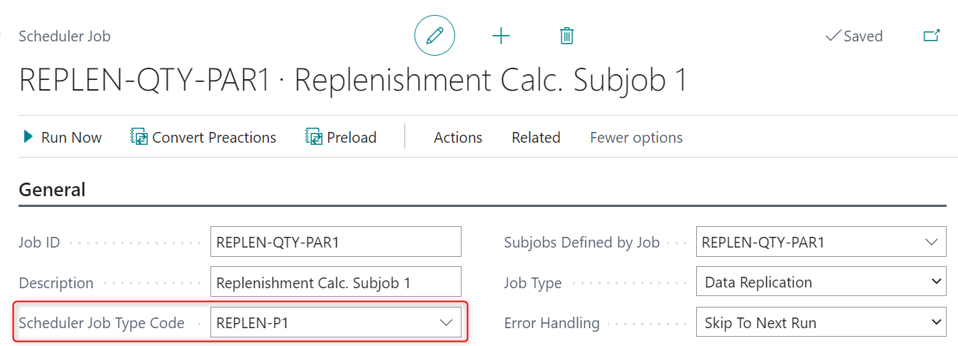
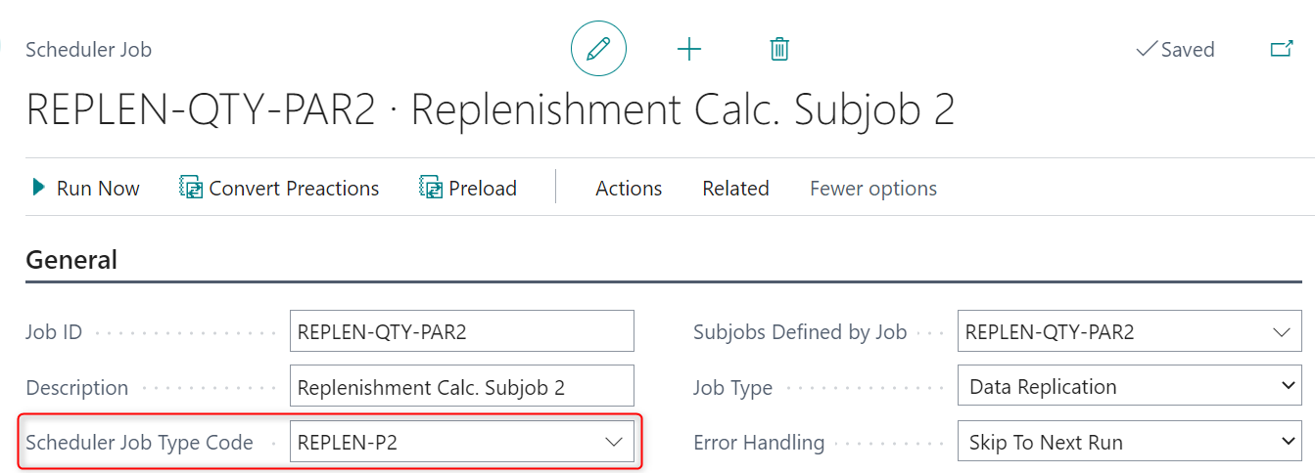

Next, you need to ensure that the Object No. field which resides in the Object Setup FastTab is assigned with codeunit 10012200 (LSC Replen. - Calc. Qtys), as this is the codeunit responsible for the RIQ calculation.
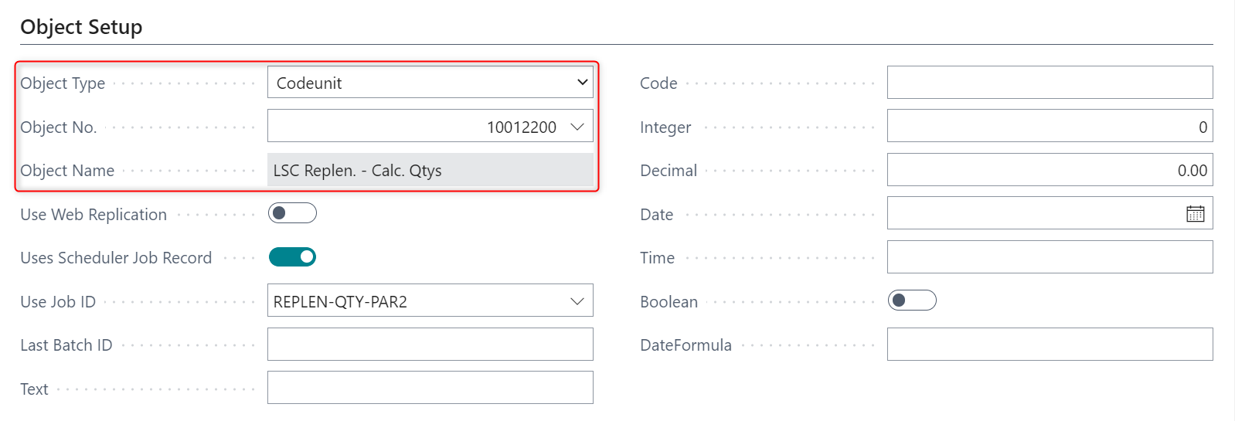

Configuring Master Scheduler Job and Linked Scheduler Jobs
A master Scheduler Job will need to be set up in order to monitor the parallel processing Scheduler Jobs that have been set up in section 2.2.3. The role of the master job is to monitor and check if all its subjobs (the parallel processing jobs) have completed their processes successfully.
Similar to setting up the parallel jobs, a unique Scheduler Job Type Code must be assigned to the master job. You must also ensure that the Object No. field is assigned with codeunit 10012221 (LSC Replen. Parallel Master) - the codeunit responsible for monitoring the parallel jobs.

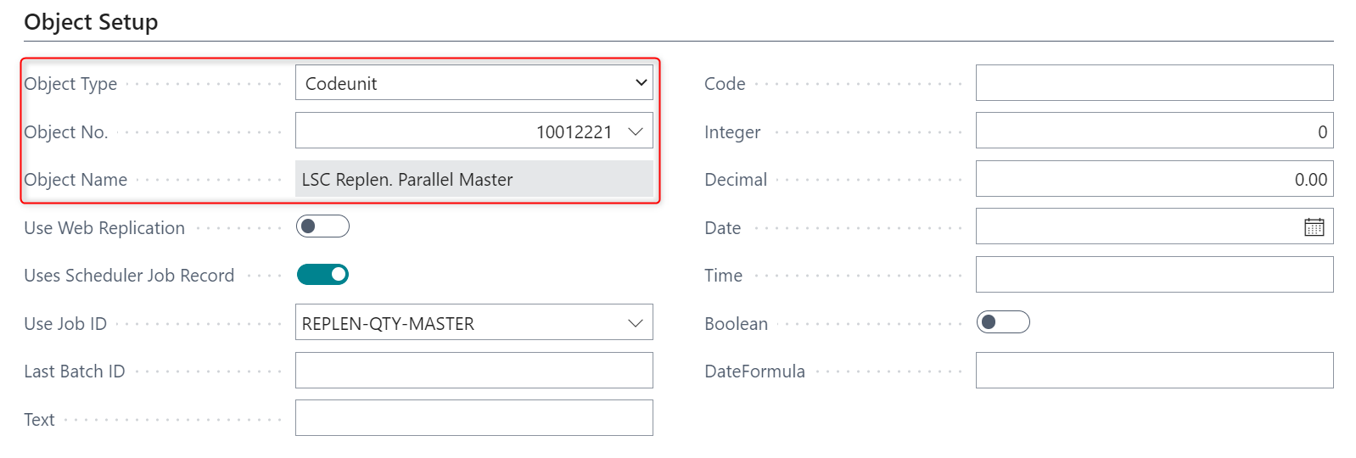

An extra step that needs to be performed when setting up the master job is to assign the relevant parallel jobs as its subjobs (Linked Scheduler Jobs). This can be done by clicking the Replenishment Parallel Jobs action located on the Related - Job action menu in the Scheduler Job card.
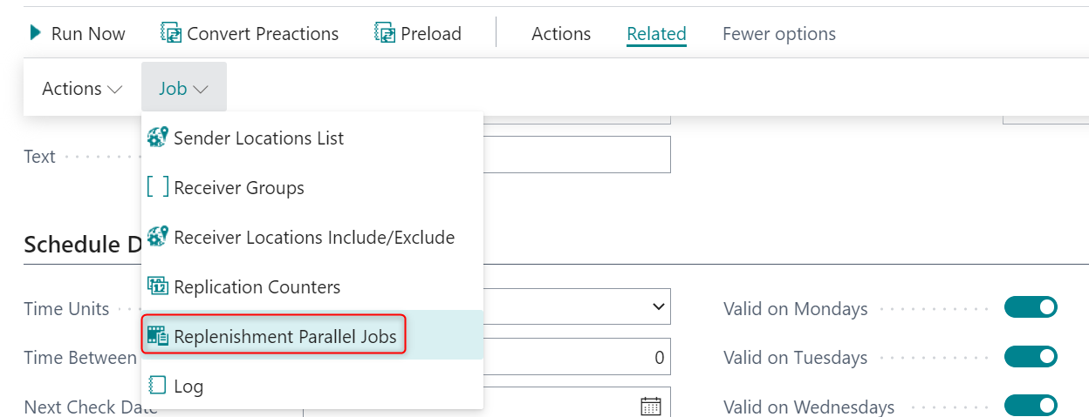

This will bring up the Replenishment Parallel Jobs card. See the screenshot below and the explanations of its fields.
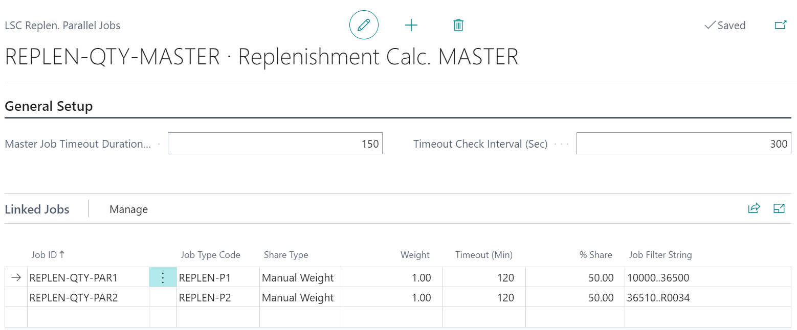

General Setup FastTab:
- Master Job Timeout Duration (Min):
  - the time in minutes that the master job should monitor the linked jobs before it times out.
  - it should not be lesser than the timeout value assigned to any linked job.
  - if it is assigned with zero, the master job will never timeout.
- Timeout Check Interval (Sec): how frequently, in seconds, the master job should check if a timeout has occured, for both master job and linked jobs.

Linked Jobs FastTab:
This is where the parallel processing jobs will be assigned to the master job as sub jobs (Linked Scheduler Jobs).
- Job ID: the ID of the parallel processing job being assigned.
- Job Type Code: the Scheduler Job Type Code assigned to the job.
- Share Type: two options are available – Equal Weight or Manual Weight.
- Weight:
  - if Share Type Equal Weight is selected, then when the Weight value of one Linked Scheduler Job is changed, the Weights of all the other jobs will be automatically updated with the same value.
  - If Share Type Manual Weight is selected, then each of the Linked Scheduler Jobs can be assigned with its individual Weight value.
- Timeout (Min):
  - the time in minutes that the linked job should run before it times out.
  - it should not be greater than the timeout value assigned to the master job.
  - if it is assigned with zero, the linked job will never timeout.
  - if a timeout occurs, the master job will be notified and the calculation process will be stopped for the affected linked job.
- % Share: the workload distributed to each linked job; this is automatically calculated based on the Weights assigned.
- Job Filter String: the range of items last processed by the linked job.

Running Out-of-Stock (OOS) Calculation in Parallel with NAS

Configuring NAS for Parallel Processing
The setup of parallel NAS for OOS is the same as the setup for RIQ. Refer to section 2.2.1 for more details.

Configuring the Primary NAS
The setup of primary NAS for OOS is the same as the setup for RIQ. Refer to section 2.2.2 for more details.

Configuring Scheduler Job for Parallel Processing
The setup of parallel processing Scheduler Job for OOS is the same as the setup for RIQ. Refer to section 2.2.3 for more details.
The one difference that you need to note is to assign the codeunit responsible for OOS calculation to the Object No. field in the Scheduler Job card. The codeunit is 10012203 (LSC Replen. Out of Stock Mgt.).
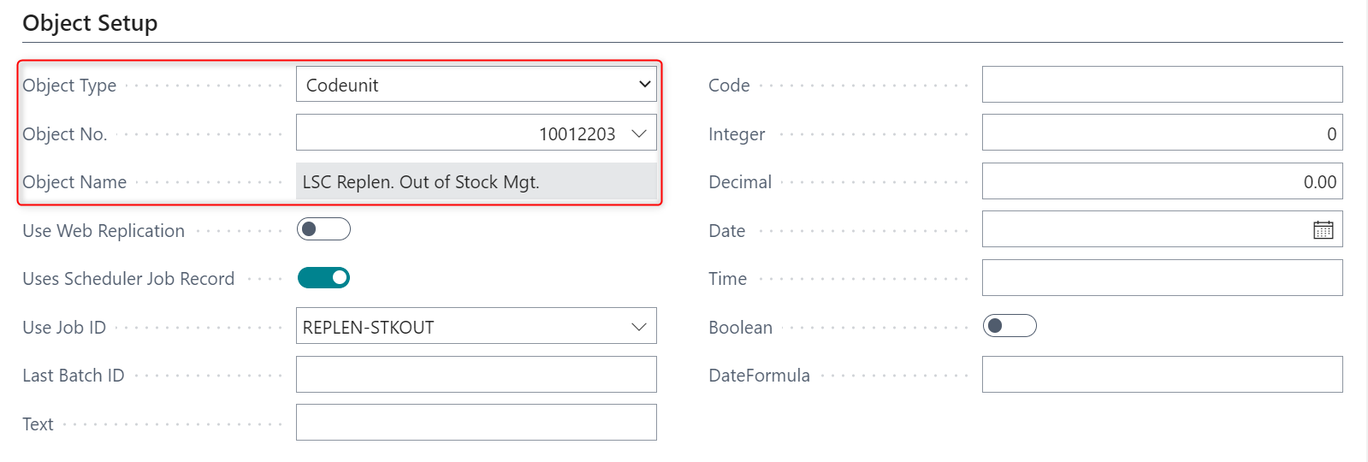

Configuring Master Scheduler Job and Linked Scheduler Jobs
The setup of master Scheduler Job and Linked Scheduler Jobs for OOS is the same as the setup for RIQ. Refer to section 2.2.4 for more details.

Replenishment Calculation Using Background Sessions

Running Replenishment Item Quantity (RIQ) Calculation in Parallel with Background Sessions

Configuring Scheduler Job for Parallel Processing
You need to define multiple Scheduler Jobs and each Scheduler Job will work on its share of the process. To run a parallel RIQ calculation, at least two Scheduler Jobs need to be configured. The Scheduler Job Type Code field is not mandatory for these Scheduler Jobs.
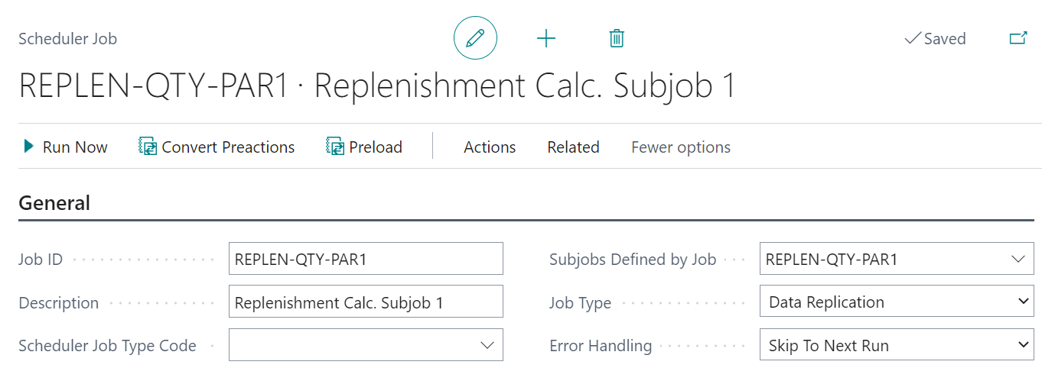

Next, you need to ensure that the Object No. Field, located in the Object Setup FastTab, is assigned with codeunit 10012200 (LSC Replen. - Calc. Qtys), as this is the codeunit responsible for the RIQ calculation.
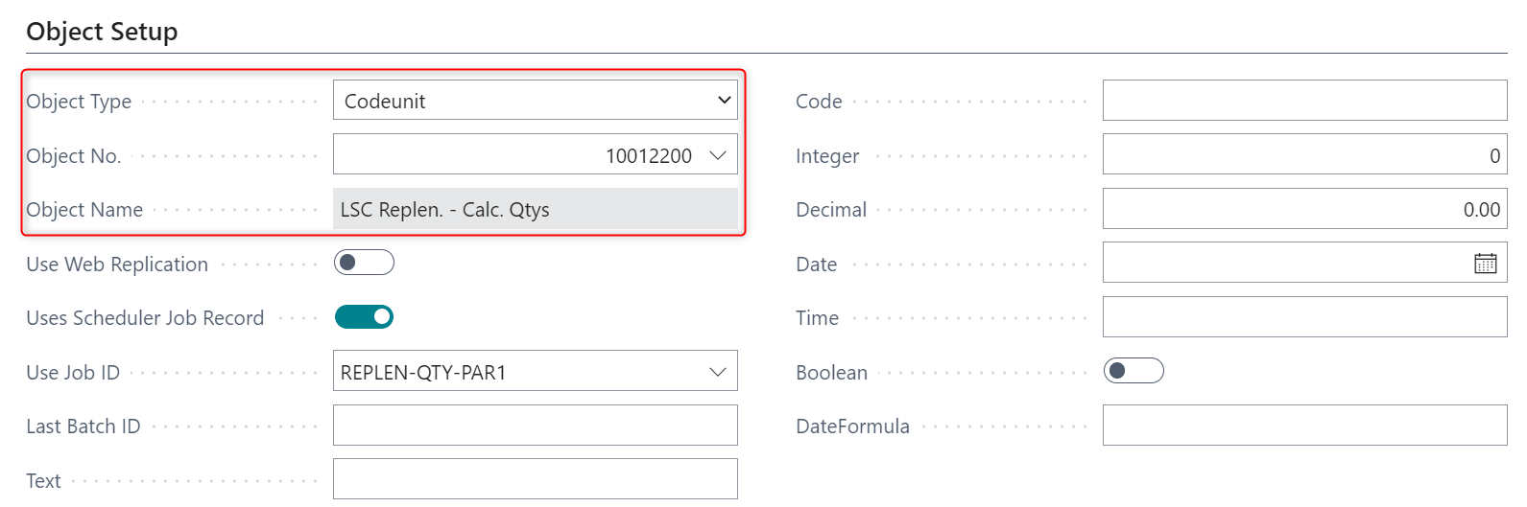
During execution, each Scheduler Job will start a background session to process the RIQ calculation.
Note: There is a maximum number of background sessions per tenant that the server instance can actively process at the same time. Requests that exceed the limit will wait in the queue until a slot becomes available. For more information, refer to Operational Limits for Business Central Online.

Configuring Master Scheduler Job and Linked Scheduler Jobs
A master Scheduler Job will need to be set up to monitor the parallel processing Scheduler Jobs that have been set up in section 3.1.1. The role of the master job is to monitor and check if all its sub jobs (the parallel processing jobs) have completed their processes successfully.
For master Scheduler Job, you must assign a Scheduler Job Type Code. You need to ensure that the Object No. field is assigned with codeunit 10012214 (LSC Replen. Parl. Master SaaS) - the codeunit responsible for running and monitoring the parallel jobs.
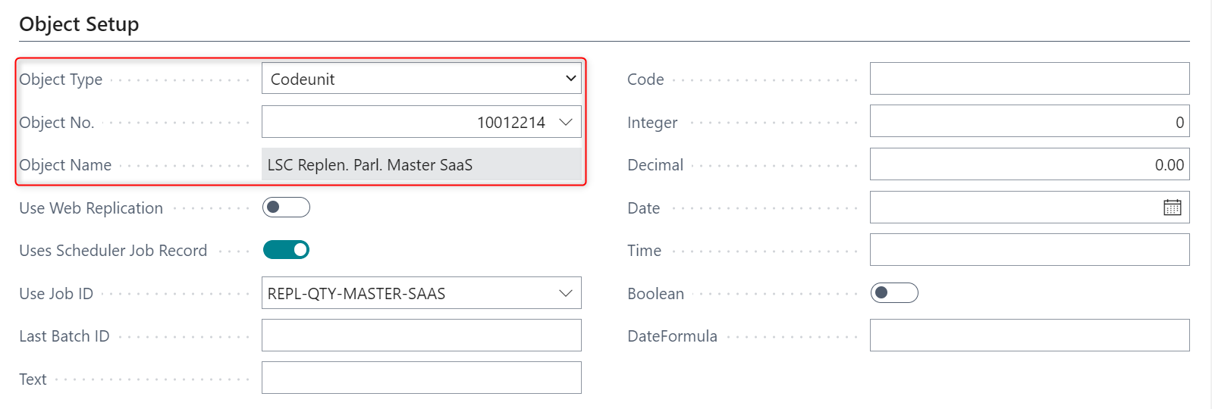

An extra step that needs to be performed when setting up the master job is to assign the relevant parallel jobs as its sub jobs (Linked Scheduler Jobs). This can be done by clicking on the Replenishment Parallel Jobs action located on the Related - Job action menu in Scheduler Job card.

This will bring up the Replenishment Parallel Jobs card. See the screenshot below and the explanations of its fields.
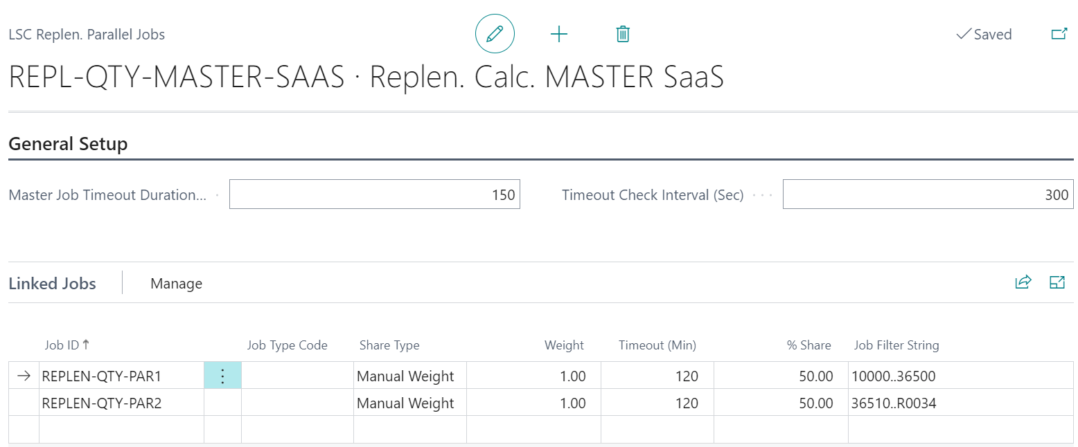

General Setup FastTab:
- Master Job Timeout Duration (Min):
  - the time in minutes that the master job should monitor the linked jobs before it times out.
  - it should not be lesser than the timeout value assigned to any linked job.
  - if it is assigned with zero, the master job will never timeout.
- Timeout Check Interval (Sec): how frequently, in seconds, the master job should check if a timeout has occured, for both master job and linked jobs.

Linked Jobs FastTab:
This is where the parallel processing jobs will be assigned to the master job as sub jobs (Linked Scheduler Jobs).
- Job ID: the ID of the parallel processing job being assigned.
- Job Type Code: the Scheduler Job Type Code assigned to the job.
- Share Type: two options are available – Equal Weight or Manual Weight.
- Weight:
  - if Share Type Equal Weight is selected, then when the Weight value of one Linked Scheduler Job is changed, the Weights of all the other jobs will be automatically updated with the same value.
  - If Share Type Manual Weight is selected, then each of the Linked Scheduler Jobs can be assigned with its individual Weight value.
- Timeout (Min):
  - the time in minutes that the linked job should run before it times out.
  - it should not be greater than the timeout value assigned to the master job.
  - if it is assigned with zero, the linked job will never timeout.
  - if a timeout occurs, the master job will be notified and the calculation process will be stopped for the affected linked job.
- % Share: the workload distributed to each linked job; this is automatically calculated based on the Weights assigned.
- Job Filter String: the range of items last processed by the linked job.

Running Out-of-Stock (OOS) Calculation in Parallel with Background Sessions

Configuring Scheduler Job for Parallel Processing
The setup of parallel processing Scheduler Job for OOS is the same as the setup for RIQ. Refer to section 3.1.1 for more details.
The one difference that you need to note is to assign the codeunit responsible for OOS calculation to the Object No. field in Scheduler Job card. The codeunit is 10012203 (LSC Replen. Out of Stock Mgt.).

Configuring Master Scheduler Job and Linked Scheduler Jobs
The setup of master Scheduler Job and Linked Scheduler Jobs for OOS is the same as the setup for RIQ. Refer to section 3.1.2 for more details.

